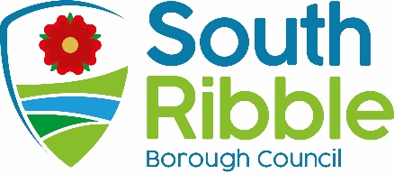

Report of | Meeting | Date
Director of Finance and Section 151 Officer | Governance Committee | Tuesday, 7 March 2023

ADDENDUM TO AGENDA ITEM 5 – FINAL AUDIT FINDINGS REPORT 2021/22

Statement of Accounts 2021/22

Is this report confidential? | No

Is this decision key? | No

Savings or expenditure amounting to greater than £100,000 | Significant impact on 2 or more council wards

Purpose of the Report

- Further to the approval of the Statement of Accounts for 2021/22 at the Governance Committee meeting on 29 November 2022, the purpose of the report is to update Committee Members on the adjustments made to the accounts since that date, following completion of the external audit by Grant Thornton.

Recommendations

- Further to the approval of the 2021/22 Statement of Accounts at the Governance Committee on 29 November 2022, the Committee is asked to approve the statements which have been amended during the completion of the external audit to include the adjustments detailed in point 10 below.

Reasons for recommendations

- At the November Governance Committee meeting, the Committee approved the 2021/22 Statement of Account, subject to any amendments which, in the opinion of the Director of Finance (Section 151 Officer), are minor in nature.

- Delegated authority was given to the Director of Finance, in consultation with the Chair of Governance Committee, to make such minor amendments, however if in the opinion of the Director of Finance any such amendments were found to be material to the financial position of the council, then Governance Committee would be asked to approve the updated Statement of Accounts

Other options considered and rejected

- The Statement of Accounts are prepared in the form to meet professional accounting standards and to comply with statutory regulations. There are therefore no alternative options that can be adopted. The report complies with the recommendations approved by Governance Committee in November 2022.

Corporate priorities

- The report relates to the following corporate priorities:

An exemplary council | Thriving communities
A fair local economy that works for everyone | Good homes, green spaces, healthy places

Background to the report

- Once the external audit has been completed, the Regulations specify that the responsible financial officer must reconfirm on behalf of the authority that they are satisfied that the statement of accounts present a true and fair view of the financial position of the authority at the year end, and the income and expenditure for the year. The council is then required to:
- consider, either by way of a committee, or by the members meeting as a whole, the statement of accounts;
- approve the statement of accounts by a resolution of that committee or meeting;

- South Ribble Borough Council delegates the responsibility for the approval of the accounts to the Governance Committee.

- The Governance Committee approved the 2021/22 Statement of Accounts at their meeting on 29 November subject to any amendments, which in the opinion of the Director of Finance are material to the financial position of the council; in such cases the Governance Committee would be asked to approve the updated Statement of Accounts.

- As noted in the Audit Findings Report on the agenda, presented by Grant Thornton, the external auditors have now completed their audit work. In doing so, since 29 November they have identified 4 adjustments required to the accounts which they have discussed with the Director of Finance and her team; these amendments have been agreed and the 2021/22 Statement of Accounts updated accordingly.

- The full list of adjustments identified by Grant Thornton to the Draft Statement of Accounts published on 4 August 2022 are set out below; this can also be found in Appendix C of the Audit Findings Report.

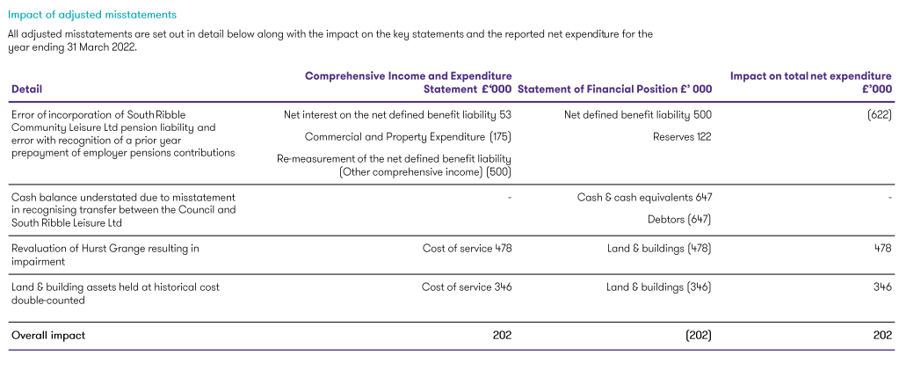

- In relation to each of the points above;

- The adjustments for the error in the incorporation of South Ribble Community Leisure Ltd pension liability and the error in the recognition of a prior year prepayment of employer pension contribution reflect the fact that the draft accounts were based on the figures provided by the actuary in their original actuarial report produced in June 2023. Following challenge and questioning by both council officers and the auditors, the actuaries revised their figures and the revisions have been adjusted for accordingly. Although the overall net impact of the misstatement on the key financial statements is immaterial, the adjustments required to the disclosure notes in the accounts are material as these reflect a breakdown of the figures in the key financial statements and are shown gross, rather than net.

- The adjustment in the cash balances relates to the consolidated accounts rather than the South Ribble Council entity accounts; this due to the fact that a transfer in income received by the council on behalf of the leisure company was treated as a cash payment in the council’s accounts but as a debtor in the leisure company’s accounts rather than a cash receipt; this has been adjusted in the leisure company’s accounts with the balance moved from Debtors to Cash;

- The revaluation of the Hurst Grange asset had not been reflected in the asset register and draft accounts; the adjustment reflects the correction of this omission.

- The final adjustment relates to double counting of component assets, i.e. assets included in the accounts as a component in their own right, which had also been included in the valuation of the overall building asset,in which they are a component part.

Climate change and air quality

- The work noted in this report does not impact the climate change and sustainability targets of the Councils Green Agenda and all environmental considerations are in place.

Equality and diversity

- This report has no implications in respect of equality and diversity.

Risk

- The accounts must be compliant with the relevant standards and must be prepared on a true and fair view basis. Failure to comply could result in a failure to meet the statutory duty.

Comments of the Statutory Finance Officer

- The report meets the statutory accounting requirements for the Statement of Accounts to be produced, which must present a factual statement of the income and expenditure flows over the course of the 2021/22 financial year, and a snapshot of the Balance Sheet position as at 31st March 2022.

- All financial implications relating to the final budget outturn position have been set out in the Revenue and Capital Outturn Reports 2021/22, and which were considered by Cabinet on 20 June 2022.

Comments of the Monitoring Officer

- The legal implications are in respect of the Accounts and Audit Regulations 2015 (as amended) 2022, and the requirement that the accounts must be compliant with the relevant accounting standards and codes of practice and must be prepared on a true and fair view basis. Failure to comply could result in a failure to meet the statutory duty.

Background documents

- Accounts and Audit (England) Regulations 2015 (as amended) 2022
- CIPFA Code of Practice on Local Authority Accounting in the United Kingdom 2021/22
.

Report Author: | Email: | Telephone: | Date:
Louise Mattinson (Director of Finance and Section 151 Officer) | louise.mattinson@southribble.gov.uk | 01772 625625 | 3 March 2023

